
Hormel Foods Corporation (Hormel)
Identity Management Foundation
Use Case Document

Contents
Version Control 4
Revision History 4
Review History 4
Approval History 4
1 Introduction 5
1.1 Executive Summary 5
1.2 Scope of Implementation 6
1.3 Target State 7
1.4 Out of Scope 7
1.5 Intended Audience 8
1.6 Key Terminologies 8
2 Process Definitions 9
2.1 User Lifecycle Management – Employees 9
2.2 Approval and Provisioning 9
3 Functional Requirements 11
3.1 User Lifecycle Management – Employees 11
3.1.1 Process#1.1 – Joiner - Employee 11
3.1.2 Process#1.2 - Rehire - Employee 13
3.1.3 Process#1.3 – Profile Change – Employee 15
3.1.4 Process#1.4 – Leaver - Employee 16
3.2 Approval and Provisioning 18
3.2.1 Process#3.1 - Approval Process 18
3.2.2 Process#3.2 - Provisioning - Active Directory 22
3.2.3 Process#3.3 - Provisioning – O365 23
3.2.4 Process#3.4 - Provisioning – Active Directory Groups 25
3.2.5 Process#3.5 - Deprovisioning – Active Directory Groups 26
3.2.6 Process#3.6 – Deprovisioning – Active Directory 27
3.2.7 Process#3.7 – Deprovisioning – O365 29
3.2.8 Process#3.8 – Enable – Active Directory 30
4 Appendix 32
4.1 Appendix A: Oracle HCM to Saviynt Identity Attributes Mapping 32
4.1.1 Identity Access Rules Triggers 33
4.2 Appendix B: Saviynt to Active Directory Mapping 33
4.2.1 Default AD Groups Provision for Users 34
4.2.2 User Status Mapping in Active Directory and Saviynt 35
4.3 Appendix C: Saviynt SSM to O365 Mapping 35
4.4 Appendix D: Birth right Rules 35
4.5 Appendix E: Business Rules 36
4.6 Appendix F: Password Policy 37
4.7 Appendix G: Email Notification 37

Table of Tables
Table 1: Key Terminologies 8
Table 2: User Lifecycle Management – Employees 9
Table 3: Approval and Provisioning 9
Table 4: Joiner - Employee 11
Table 5: Rehire – Employee 13
Table 6: Profile Change – Employee 15
Table 7: Leaver - Employee 16
Table 8: Approval Process Active Directory and O365 18
Table 9: Approval Process Active Directory Group 20
Table 10: Approval Process and Level 21
Table 11: Provisioning - Active Directory 22
Table 12: Provisioning – O365 24
Table 13: Provisioning – Active Diretory Groups 25
Table 14: Deprovisioning – Active Directory Groups 26
Table 15: Deprovisioning – Active Directory 28
Table 16: Deprovisioning – O365 29
Table 17: Enable – Active Directory 30
Table 18: Oracle HCM to Saviynt SSM Identity Attributes Mapping 32
Table 19: Identity Access Rules Triggers 33
Table 20: Saviynt to Active Directory Mapping 33
Table 21: Default AD Group Provision 34
Table 22: User Status Mapping in Active Directory 35
Table 23: Birth right Rules 35
Table 24: Birth right Rules 35
Table 25: Birth right Rules 36
Table 26: Active Directory Password Policy 37
Table 27: Email Notification 38

Table of Figures
Figure 1: Scope of IAM Business Processes 6
Figure 2: Identity Management Future State 7
Figure 3: Joiner – Employee 11
Figure 4: Rehire – Employee 13
Figure 5: Profile Change – Employee 15
Figure 6: Leaver - Employee 16
Figure 7: Approval Process for Active Directory and O365 18
Figure 8: Approval Process for Active Directory Group 20
Figure 9: Provisioning - Active Directory 22
Figure 10: Provisioning – O365 23
Figure 11: Provisioning – Active Directory Groups 25
Figure 12: Deprovisioning – Active Directory Groups 26
Figure 13: Deprovisioning – Active Directory 27
Figure 14: Deprovisioning – O365 29
Figure 15: Enable – Active Directory 30

Version Control

Revision History
This section represents the change history of the document. All revisions of the document must be tracked by identifying a new version number, the date it was modified, the person making the change, and the reason for the change.
Version | Date | Author | Comments
0.1 | 10/16/2020 | Anjali Patil | Initial Draft
0.2 | 10/19/2020 | Vineet Gupta
0.3 | 10/20/2020 | Anjali Patil | Incorporated Vineet’s review comment.

Review History
Version | Reviewed By | Date

Approval History
The signing of this document acknowledges everyone’s concurrence with the validity and accuracy of the information contained in this document.
Version | Approved By | Date

Introduction

Executive Summary
Hormel Foods Corporation (Hormel) has embarked upon a technology-driven transformation initiative for its Identity and Access Management (IAM) program. The key objective of this initiative is to implement Saviynt Identity Management platform as the strategic solution that will be used to automate enterprise users’ lifecycle and access management across key systems.
The purpose of this document is to define the IAM business processes that will be developed using Saviynt as part of this initiative. Follow up deliverables, including design document and technology implementation will refer to and support the specifics of processes defined in this document.
It is noted that currently Hormel use a combination of custom developed capabilities and manual tasks to enable these business processes. With the implementation of Saviynt, IAM processes are expected to become more formalized, standardized, automated and reduce the overall risk of un-authorized access within Hormel.
The scope of the user base that will be affected by this change is limited to Employees for current phase.

Scope of Implementation
Following diagram provides a brief overview of IAM processes and applications covered within the scope of this initiative:
Figure 1: Scope of IAM Business Processes
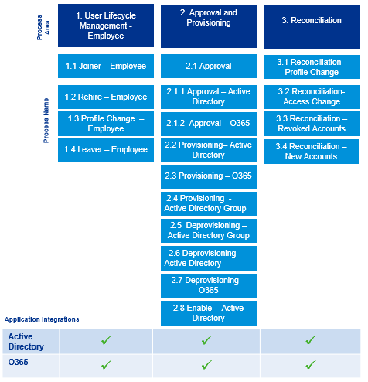

Target State
Figure 2: Identity Management Future State
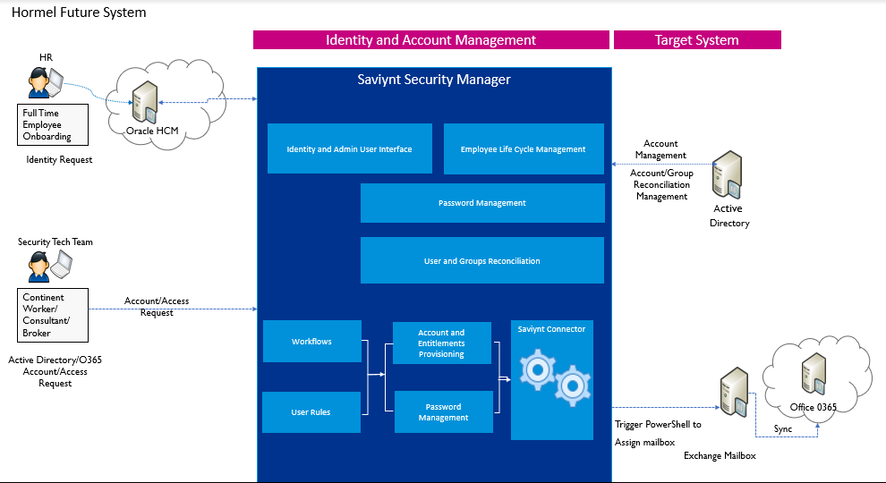

Figure 2 depicts the future state of the Identity Management processes to be achieved during this initiative. In future state,
- Saviynt Security Manager (SSM) will become the standards platform to manage identity and access of personnel and automate a number of manual processes. Employee data will be imported from HCM. SSM will import the HR data and will automate Active Directory and O365 account management based on user’s lifecycle rules (i.e. joiner and leaver processes) within the Hormel for Employees.
- As part of the initial (or Day 0) load, existing Employee and Contingent Workers account/entitlement data will be imported into the Identity Management System from Active Directory, O365 and future changes will be managed via SSM except mover process.
- For Employee Active Directory and O365 accounts will be provisioned as Birth Right depend on Birth Right rule.
- For Contingent worker/Consultant/Broker security tech team will raise the request for Active Directory and O365 account based on CAS request they receives.
- Saviynt will automate rest of the lifecycle and request / approval management for access in Active Directory and O365.

Out of Scope
- Any technology integration not specifically identified as Application Integration in Section 1.2 is not in scope.
- Management of non-person accounts (system / service accounts) is not in scope.
- Application Inventory analysis and Application onboarding framework to onboard future applications.
- Single sign on integration of Saviynt application with Enterprise Access Management Solution.
- LOA and Long term disability is out of scope for this phase.
- Mover use cases for Identity and changes to downstream application on identity move is out of scope.
- Password management for Active Directory is not in scope of this phase.
- Immediate termination (emergency termination process) of Identity from Saviynt is not in scope.
- Home directory creation for Active Directory account is out of scope of this phase.
- Enable of mailbox is out of scope.

Intended Audience
- The primary audience for this document is the business owners of the proposed system. This document should be readable by these business owners, and they must be able to verify that their business requirements have been documented here completely, accurately, and unambiguously.
- Project team and stakeholders, whose role would be to review and confirm the scope and details of the business and non-functional requirements as captured by KPMG.
- Data Architects, Application Architects, and Technical Architects would also find the information in this document useful when they need to design a solution that will address these business requirements.

Key Terminologies
Table 1: Key Terminologies
Terminology | Definition
Employee | Full / Part-time Employees on Hormel’ payroll who are managed via the Hormel’s HR system.
Other Users | Contractor/Consultants or Contingent worker which are currently created in Active Directory directly then they are created in HCM.
Identity | Identity is a system of record that is uniquely associated with a user within an organization. Each user, full time, part-time, Contractor or Consultant within Hormel should have one and only one identity. In mature IAM programs, and identity is uniquely defined using a UserName, which would stay with the user for life.
Account | An account is a system of record that is associated with various technologies users gain access to, for example, Active Directory, O365, etc. An IAM system would link identities to accounts across various integrated technologies. An identity may have none, one or more accounts based on the environment. If an account can’t be associated with an identity, it is considered an orphan account. Having such accounts adds the risk of unauthorized access to an organization.
Up-stream System | A up-stream system refers to the authoritative source of user records within an organization. At Hormel, Oracle HCM is considered the up-stream system for Employees.
Down-stream system | A downstream system refers to integration applications or technologies in which accounts are managed by IAM technologies. For the scope of this engagement, downstream systems collectively refer to Active Directory, O365

Process Definitions
This section describes the business requirements. The business requirements comprise of Joiner and Leaver process for Employees.

User Lifecycle Management – Employees
This process area covers the user lifecycle of Employees. Data about joiner employees are expected to be received from up-stream Oracle Cloud HCM, which is the standard HR system at Hormel.
Table 2: User Lifecycle Management – Employees
P# | Name | Definition
1.1 | Joiner – Employee | The solution (Saviynt Security Manager) shall have the ability to automatically connect to the up-stream HR System to identify new Employees, create new identity record in Saviynt repository with unique ID and provision accounts and accesses in connected downstream platforms based on pre-approved birth right rules.
1.2 | Rehire – Employee | The solution shall have the ability to automatically connect to the up-stream HR System to identify employees that have been re-hired and re-enable their identity record in Saviynt repository and enable accounts and accesses in connected downstream systems based on pre-approved birth right rules.
1.3 | Profile Change – Employee | The solution shall have the ability to automatically connect to the up-stream HR system, identify users whose profile attributes have been updated, and update associated accounts in connected downstream systems.
1.4 | Leaver - Employee | The solution shall have the ability to automatically connect to up-stream HR System, identify terminated users and automatically disable or delete user accounts in downstream systems(wherever applicable).

Approval and Provisioning
This process area covers the standardized access request and approval process for the systems integrated with Saviynt.
Table 3: Approval and Provisioning
P# | Name | Definition
3.1 | Approval Process | The system shall provide a web interface for users (requesters) to submit requests on behalf of other users or for self, and appropriate approvers to approve requests for access to a new account, or additional entitlements on Active Directory and O365.
3.2 | Provisioning – Active Directory | The system shall have the ability to automatically create an account and assign additional entitlements to an identity based on approved requests or pre-approved birth-right rules.
3.3 | Provisioning– O365 | The system shall have the ability to automatically create an account for an identity based on approved requests or pre-approved birth-right rules on O365.
3.4 | Remove Access | The system shall provide a web interface to users’s managers and/or IAM administrators to remove access or accounts within connected systems.

Functional Requirements

User Lifecycle Management – Employees

Process#1.1 – Joiner - Employee
Figure 3: Joiner – Employee
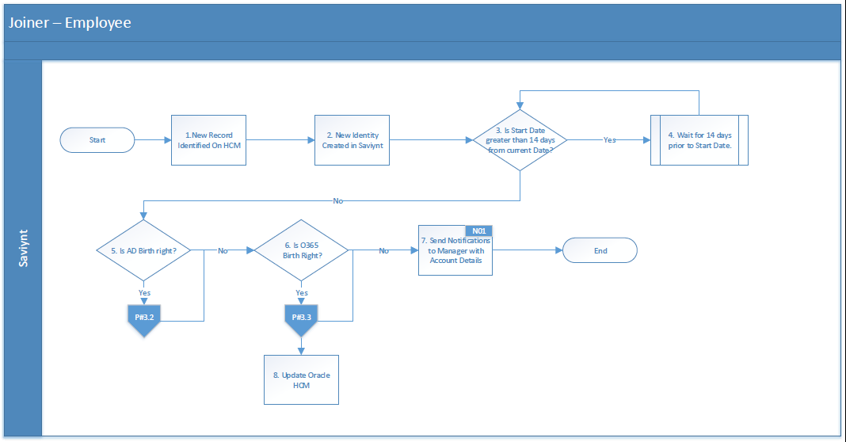
Table 4: Joiner - Employee
Process Description | The solution shall have the ability to automatically connect to the up-stream Oracle HCM to identify new Employees, create new identity record in Saviynt with Unique ID and birth right accounts, including access in connected downstream systems, wherever access has pre-approved for the users based on their employee data.
Actors | HR Administrator, Saviynt
Preconditions | - HR Administrator has created a new Employee record on Oracle HCM. This record doesn’t have any previously assigned Email Address or User Id and a new Person Number has been generated in HCM.
Triggers | - HR Administrator has created a new Employee record on Oracle HCM.  - Saviynt’s user import job has been triggered, which fetches all the Active and Inactive Employee records from Oracle HCM
Process Details | This section provides additional details about the process flow defined above. Each number corresponds to equivalent step on the flow diagram. Additional details may include appropriate references for evaluation logic, transformation mappings.  - HR Administrator enters Employee records in the Oracle HCM System.  - New Record Identified on Oracle HCM by Saviynt.  - No other record found with the same Person Number on Saviynt.  - User Name field is empty on HCM.  - New Identity is Created in Saviynt.  - New user identity will be created in Saviynt. For Oracle HCM attributes to Saviynt attribute mapping, please refer to Appendix A.  - Unique User ID will be created for new user in Saviynt.Refer to Appendix E for User Id Creation rule (BR004).  - Is Start Date greater than 14 days from current Date?  - User’s Assignment on Oracle HCM is “Pending New Hire” and users Start Date is less than 14 days or equal to current date in the UTC zone then all the birth right rules will be evaluated for the users.  - Wait for 14 days prior to Start Date.  - If users Start Date is greater than 14 days from current date then birth right rule will not be evaluated till the start date is less than 14 days from current date.  - Is AD Birth right?  - Depend on Active Directory birth right rule Active Directory will be provisioned to the user.  - Refer to Appendix D for Active Directory Birth right rules  - Is O365 a birth right?  - Depend on O365 birth right rule O365 account will be provisioned to the user.  - Refer to Appendix D for O365 Birth right rules  - Send Notification to Manager with Account Details  - Refer to Appendix A to identify the user’s Manager on Saviynt SSM.  - Refer to Appendix G for the Email notification template N01.  - Update Oracle HCM  - Refer to Special Requirement section below for more details.
Post Condition | - All new hire identities must be created in the IAM system and provisioned to appropriate target applications.
Special Requirement | - When user wil get the Email address after O365 account provisioning, that newly generated email address needs to be populated on HCM profile of the user.
Exceptions | - Provisioning failures may happen to the downstream systems. Refer to corresponding process ids (P#3.2, P#3.3, P#3.4 and P#3.5)
Assumptions | - HR System has Employee, Pending Worker records and Contingent Worker data. Saviynt should be able to pull all records.  - There are no duplicate entries in the Oracle HCM for any given Employee.  - Critical attributes that indicate the action that is required for the given record (i.e. create, update, enable and disable) are correctly updated in the HR System.  - Connection to Active Directory is always available.

Process#1.2 - Rehire - Employee
Figure 4: Rehire – Employee
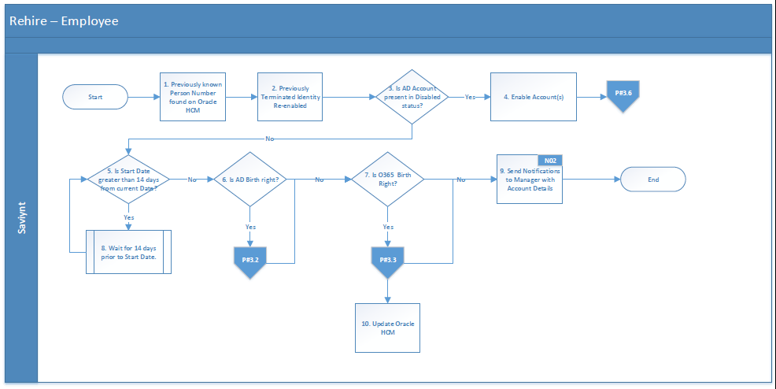
Table 5: Rehire – Employee
Process Description | The solution shall have the ability to automatically connect to the up-stream Oracle HCM to identify Employees, which have been re-hired and re-enable identity record and birth right accounts, including access in connected downstream systems, wherever access has pre-approved for the users based on their employee data.
Actors | HR, Saviynt
Preconditions | - This record has a previously assigned Person Number.
Triggers | - HR Administrator has re-hired an existing Employee record on Oracle HCM.  - Saviynt triggers the user import job to fetch all the Active and Inactive Employee records from Oracle HCM.
Process Details | This section provides additional details about the process flow defined above. Each number corresponds to equivalent step on the flow diagram. Additional details may include appropriate references for evaluation logic, transformation mappings.  - Previously known Person Number found on Oracle HCM  - HR Administrator rehires the existing terminated user.  - The corresponding Identity exists in Saviynt with identity status as Inactive.  - Previously terminated identity re-enabled.  - The existing inactive users identity gets enabled on Saviynt.  - Refer to Appendix A for HCM to Saviynt Profile Attributes Mapping.  - Enable Accounts  - The existing account assigned to the user will be enabled.  - Refer to Appendix B for corresponding “Enabled” status on AD.  - Is Start Date greater than 14 days from current Date?  - User’s Assignment on Oracle HCM is “Pending New Hire” and users Start Date is less than 14 days or equal to current date in the UTC zone then all the birth right rules will be evaluated for the users.  - Wait for 14 days prior to Start Date.  - If users Start Date is greater than 14 days from current date then birth right rule will not be evaluated till the start date is less than 14 days from current date.  - Is AD Birth right?  - Depend on Active Directory birth right rule Active Directory will be provisioned to the user.  - Refer to Appendix D for Active Directory Birth right rules  - Is O365 a birth right?  - Depend on O365 birth right rule O365 account will be provisioned to the user.  - Refer to Appendix D for O365 Birth right rules  - Is Pending New Hire?  - User’s Assignment on Oracle HCM is “Pending New Hire” and users Start Date is less than 14 days or equal to current date in the UTC zone then all the birth right rules will be evaluated for the users.  - Send Notification to Manager with Account Details  - Refer to Appendix A to identify the user’s Manager on Saviynt SSM.  - Refer to Appendix G for the Email notification template N02.  - Update Oracle HCM  - Refer to Special Requirement section below for more details.
Post Condition | - All new rehire identities must be enabled in the IAM system and provisioned to appropriate target applications.
Special Requirement | When user wil get the Email address after O365 account provisioning, that newly generated email address needs to be populated on HCM profile of the user.
Exceptions | - Provisioning failures may happen to the downstream systems. Refer to corresponding process ids (P#3.2, P#3.3, P#3.4 and P#3.5).
Assumptions | - HR System has Employee, Pending Worker records and Contingent Worker data. Saviynt should be able to pull all records.  - There are no duplicate entries in the HR System for any given Employee.  - Critical attributes that indicate the action that is required for the given record (i.e. create, update, enable and disable) are correctly updated in the HR System.  - Connection to Active Directory is always available.

Process#1.3 – Profile Change – Employee
Figure 5: Profile Change – Employee
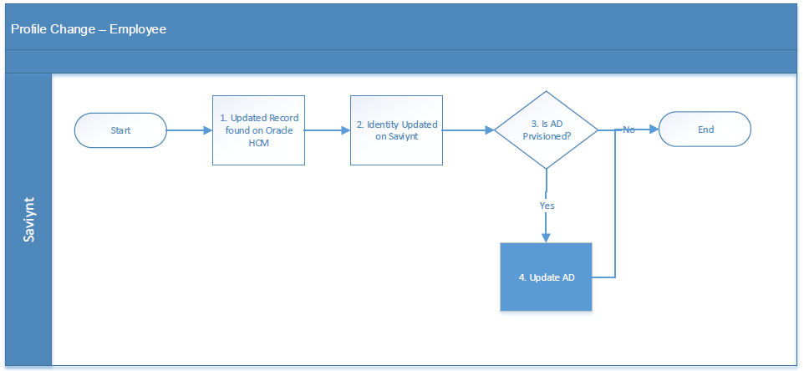
Table 6: Profile Change – Employee
Process Description | The solution shall have the ability to automatically connect to the up-stream HR system, identify users whose profile attributes have updated, and update associated accounts in connected downstream systems.
Actors | HR, Saviynt
Preconditions | - Employee record present on Oracle HCM in Active status.
Triggers | - HR Administrator has updated an Employee record on Oracle HCM in fields that are significant for Saviynt.  - Identity is updated on the Saviynt via the Authoritative source reconciliation process.
Process Details | This section provides additional details about the process flow defined above. Each number corresponds to equivalent step on the flow diagram. Additional details may include appropriate references for evaluation logic, transformation mappings.  - Updated record found on Oracle HCM  - HR Administrator updates the attribute of user on HCM profile.  - Identity Updated on Saviynt  - The changed attribute in HCM gets updated in Saviynt identity profile of user.  - Refer to Appendix A for HCM to Saviynt Profile Attributes Mapping.  - Is AD Provisioned?  - Saviynt Identity must have at least 1 Active Directory account linked to it to update the attribute in Active Directory.  - Update Active Directory  - Refer to Appendix B for Attribute Mapping
Post Condition | - Personnel attributes are updated in the Saviynt and respective target system.
Exceptions | - User identity update may fail due to data discrepancy. In such a case, send an email to the IAM Support mailbox using Template N07.  - Downstream provisioning may fail due to data discrepancy or network issues. In such a case, send an email to the IAM Support mailbox using template N07.
Assumptions | - HR System has Employee, Pending Worker records and Contingent Worker data. Saviynt should be able to pull all records.  - There are no duplicate entries in the HR System for any given Employee.  - Critical attributes that indicate the action that is required for the given record (i.e. create, update, enable and disable) are correctly updated in the HR System.  - Connection to Active Directory is always available.

Process#1.4 – Leaver - Employee
Figure 6: Leaver - Employee
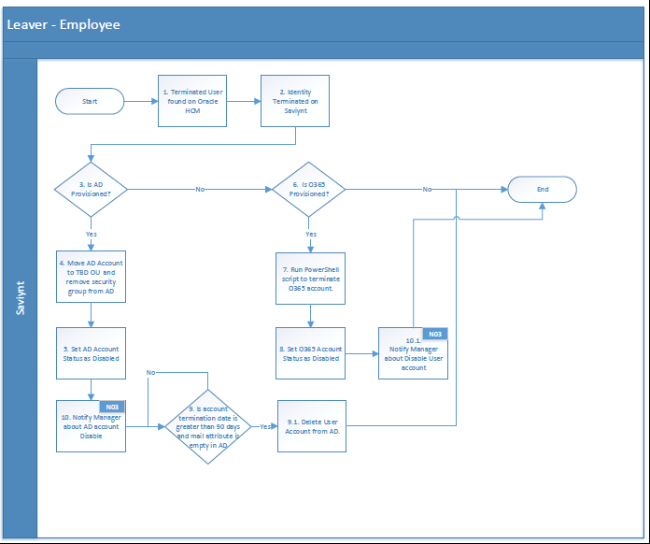
Table 7: Leaver - Employee
Process Description | The solution shall have the ability to automatically connect to the up-stream HR system, identify users whose profile got inactivated, and disable associated accounts in connected downstream systems.
Actors | HR, Saviynt
Preconditions | - HR Administrator has terminated an Employee record on Oracle HCM.  - User’s termination date has been notified to HR  - HR must update the employee end date and status in an authoritative source (HCM).  - HR changes the user’s status to ‘’Terminated” and set the the termination date  - IAM system synchronizes with HCM to find the user(s) that are terminated
Triggers | - HR Administrator has updated an Employee record on Oracle HCM in fields that are significant for Saviynt.  - Identity is updated on the Saviynt via the Authoritative source reconciliation process.  - Employee status changes to ‘Inactive’ in Saviynt.
Process Details | This section provides additional details about the process flow defined above. Each number corresponds to equivalent step on the flow diagram. Additional details may include appropriate references for evaluation logic, transformation mappings.  - Terminated User found on Oracle HCM  - HR Administrator update the users End date and status to terminate.  - Refer to Appendix A for HCM to Saviynt Profile Attributes Mapping.  - Identity Terminated on Saviynt  - The existing active users identity gets disabled on Saviynt.  - Refer to Appendix A for HCM to Saviynt Profile Attributes Mapping.  - Is AD Provisioned?  - Saviynt Identity must have at least 1 Active Directory account linked to it.  - Move AD Account to TBD OU and remove security group from AD.  - Move AD account to TBD OU  - Security group assigned to the user are removed  - Set Active Directory Account Status to Disabled  - Refer to Appendix B for corresponding “Disable” status on AD.  - Is O365 Provisioned?  - Saviynt Identity must have at least 1 O365 account linked to it.  - Run PowerShell script to terminate O365 account.  - Set O365 Account Status to Disabled.  - Is account termination date is greater than 90 days and mail attribute is empty in AD  - Active Directory account will be deleted after 90 days once it’s disabled.  - If termination date is less than 90 days then account stays in TBD OU in Disable state.  - Notify Manager about Terminated User  - Refer to Appendix A to identify the user’s Manager on Saviynt.  - Refer to Appendix G for the Email notification template N03.  - Refer to Appendix G for the Email notification template N10.
Post Condition | - IAM system must disable the identity and disable all provisioned target applications.
Exceptions | - Downstream provisioning may fail due to data discrepancy or network issues. In such a case, send an email to the IAM Support mailbox using template N07.
Assumptions | - HR System has Employee, Pending Worker records and Contingent Worker data. Saviynt should be able to pull all records.  - There are no duplicate entries in the HR System for any given Employee.  - Critical attributes that indicate the action that is required for the given record (i.e. create, update, enable and disable) are correctly updated in the HR System.  - Connection to Active Directory is always available.

Approval and Provisioning

Process#3.1 - Approval Process

Process#3.1.1 - Approval Sub-Process for Active Directory and O365
Figure 7: Approval Process for Active Directory and O365
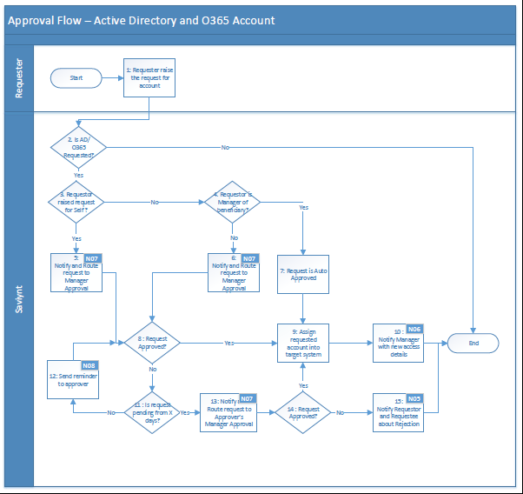
Table 8: Approval Process Active Directory and O365
Process Description | The system shall provide a web interface to Beneficiary, Beneficiary’s Manager,End User to submit requests on behalf of other users, and appropriate approvers to approve requests for access to a new account, or additional entitlements on downstream systems.
Actors | - Saviynt  - Requester (Beneficiary, Beneficiary’s Manager,Any other End User)  - Manager
Preconditions | - An Active Identity exists on Saviynt that was created as Employee via Oracle HCM.  - Identity doesn’t have the account which will be requested.
Triggers | - Requester submits an access request within the Saviynt.
Process Details | - Approval Process at Hormel is a serial workflow with one or more steps.  - Approvers are dependent upon who has made the request, and what has been requested.  - An approval process is consensus-based; i.e. request must be approved at every level. Any Denial will immediately end the workflow with no access grant.  - Table 10 below provides details about the expectations  - Refer to Appendix G for the Email notification template N05,N06,N07,N08.
Exceptions | - Denial of request at any workflow stage would immediately end the workflow.  - Requests will be cancelled if no action has been taken at a stage in the workflow for 10 days.  - If Saviynt is unable to find an appropriate approver at any stage, e.g. User has no manager, it will be routed to IAM Admin.
Post Condition | - A account is assigned to the Requestee in the IAM system. IAM system provisions new accounts based on the request.
Assumptions | - No downstream changes will be made to the user’s access and IAM Admin is expected to reach out to the user and assist them to gain access to needed systems.

Process#3.1.2 - Approval Sub-Process for Active Directory Group
Figure 8: Approval Process for Active Directory Group
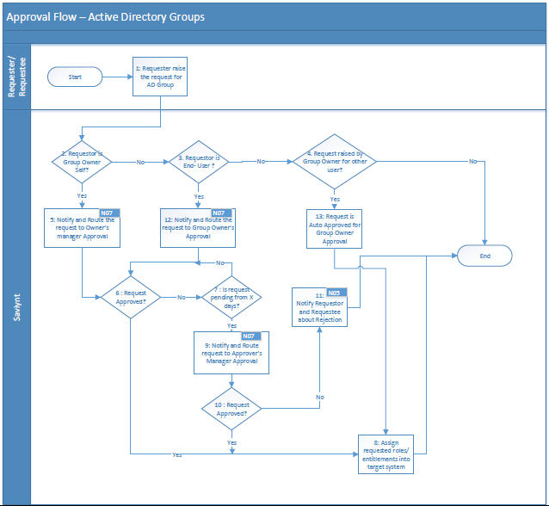
Table 9: Approval Process Active Directory Group
Process Description | The system shall provide a web interface for requesters to submit requests on behalf of other users and for self, and appropriate approvers to approve requests for access to additional entitlements on downstream systems.
Actors | - Saviynt  - Requester (Beneficiary, Beneficiary’s Manager, Entitlement Owner)  - Manager  - Group Owners
Preconditions | - An Active Identity exists on Saviynt that was created as Employee via Oracle HCM.  - Identity doesn’t have the entitlement, which will be requested.
Triggers | - Requester submits an access request within the Saviynt.
Process Details | - Approval Process at Hormel is a serial workflow with one or more steps.  - Approvers are dependent upon who has made the request, and what has been requested.  - An approval process is consensus-based; i.e. request must be approved at every level. Any Denial will immediately end the workflow with no access grant.  - Table 10 below provides details about the expectations  - Refer to Appendix G for the Email notification template N05.  - Refer to Appendix G for the Email notification template N07.
Exceptions | - Denial of request at any workflow stage would immediately end the workflow.  - Requests will be cancelled if no action has been taken at a stage in the workflow for 10 days.  - If Saviynt is unable to find an appropriate approver at any stage, e.g. User has no manager,it will be routed to IAM Admin.
Post Condition | - A role/entitlement is assigned to the Requestee in the IAM system. IAM system provisions new entitlements based on request raised.
Assumptions | - No downstream changes will be made to the user’s access and IAM Admin is expected to reach out to the user and assist them to gain access to needed systems.

Table 10: Approval Process and Level
 |  | Approval Levels
Application | Requester | Manager | Manager’s Manager | AD Group Owner | AD Group Owner’s Manager
Active Directory, O365 Account Provisioning | Self
Active Directory, O365 Account Provisioning | Manager for Other User | Auto Approve
Active Directory, O365 Account Provisioning | Approver not taken action for 4 days
Active Directory Group Provisioning | Self
Active Directory Group Provisioning | Group Owner for Self
Active Directory Group Provisioning | Group Owner for Other |  | Auto Approve
Active Directory Group Provisioning | Approver not taken action for 4 days
Active Directory , O365 account Deprovisioning |  | Auto Approve
Active Directory Group Deprovisioning |  | Auto Approve

Additional Capabilities
Cancel Request after 10 days of inaction
Send 3rd day Reminders
Allow re-routing to request to requester for additional information

Process#3.2 - Provisioning - Active Directory
Figure 9: Provisioning - Active Directory
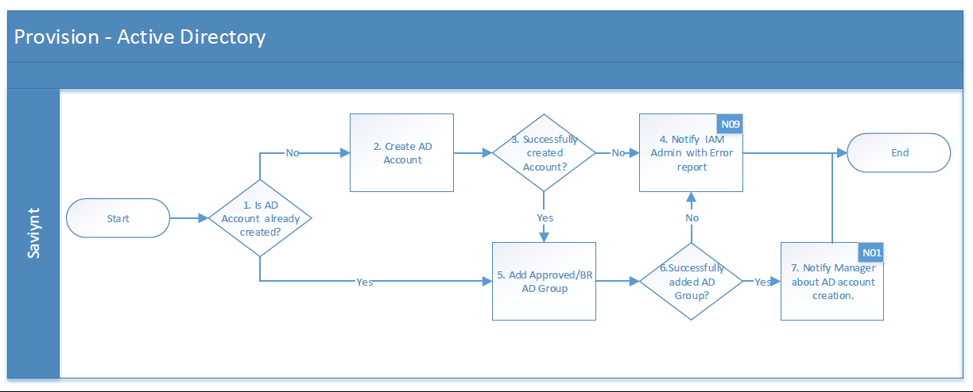
Table 11: Provisioning - Active Directory
Process Description | The system shall have the ability to automatically create or assign additional entitlements to an identity based on approved requests or pre-approved birth-right rules.
Actors | - Saviynt
Preconditions | - Request for access for the user has been approved, or,  - Access is granted as a birth right to the user.
Triggers | - Requester submits an access request within the Saviynt.  - Refer Appendix D for the birth right rule.
Process Details | This section provides additional details about the process flow defined above. Each number corresponds to equivalent step on the flow diagram. Additional details may include appropriate references for evaluation logic, transformation mappings.  - Is the AD Account already created?  - An Active AD Account must be linked to the identity on Saviynt.  - Create AD Account.  - AD account will be created and attribute mapping should be done based on Appendix B.  - OU selection will be done as per the HCM location present on user profile.  - Successfully created Account?  - AD Command returns success and AD account will be provisioned to user in Saviynt.  - Notify IAM Admin with error if operation fails.  - If any error occurs while creating AD account, an email notification will be sent to the IAM Administrator mailbox.  - Refer to Appendix G for the Email notification template N07.  - Add Approved AD/Birth Right Group  - Assign the AD group as per the request or calculate the birth right group as per Birth Right policy and assign the group to AD account.  - Successfully added AD Group?  - AD Command returns success and AD group will be added to AD account in Saviynt.  - Notify Manager about AD account creation.  - Email notification will be sent to Manager with AD user name and first time password.
Post Condition | - An AD account with AD group will be created in Saviynt and in AD target system.
Exceptions | - If all the required attribute are not present for AD account creation then provisioning will fail.
Assumptions | NA

Process#3.3 - Provisioning – O365
Figure 10: Provisioning – O365
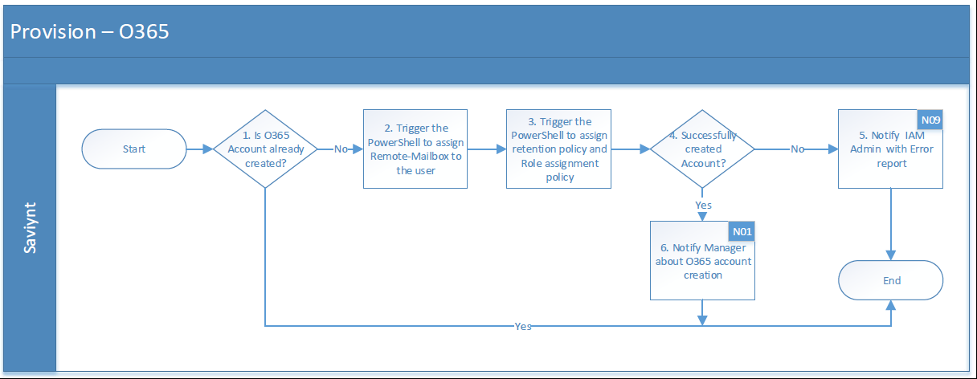

Table 12: Provisioning – O365
Process Description | The system shall have the ability to automatically assign O365 licenses and assign Exchange Mailbox to an identity based on approved requests or pre-approved birth-right rules.
Actors | - Saviynt
Preconditions | - Request for access for the user has been approved, or,  - Access is granted as a birth right to the user.
Triggers | - Requester submits an access request within the Saviynt.  - Refer Appendix D for the birth right rule.
Process Details | This section provides additional details about the process flow defined above. Each number corresponds to equivalent step on the flow diagram. Additional details may include appropriate references for evaluation logic, transformation mappings.  - Is the O365 Account already created?  - An Active O365 Account must be linked to the identity on Saviynt.  - Trigger the PowerShell to assign Remote-Mailbox to the user  - O365 account will be created and attribute mapping should be done based on Appendix C.  - Enable exchange with primary email address.  - Enable Email address policy and add the primary email address for mailbox.  - If users UPN is not same as email address then update the UPN to email value in Saviynt.  - Trigger the PowerShell to assign retention policy and Role assignment policy.  - Successfully created Account?  - PowerShell script returns success and O365 account will be provisioned to user in Saviynt.  - Notify IAM Admin with error if operation fails.  - If any error occurs while creating O365 account, an email notification will be sent to the IAM Administrator mailbox.  - Refer to Appendix G for the Email notification template N09.  - Notify Manager about O365 account creation.
Post Condition | - Exchange Mailbox is assigned to the user.
Exceptions | - Failure of API should trigger an email-based notification to the IAM Support mailbox using email template N09.
Assumptions | - PowerShell script that is used today to create mailboxes can be used with minimal modifications. Development of new PowerShell script would require additional effort.  - It is assumed that the Microsoft Azure account setup is performed via a separate process. If that process has not yet synchronized user’s account, the script execution may fail. In such a case, Saviynt would retry in 8 hours.

Process#3.4 - Provisioning – Active Directory Groups
Figure 11: Provisioning – Active Directory Groups
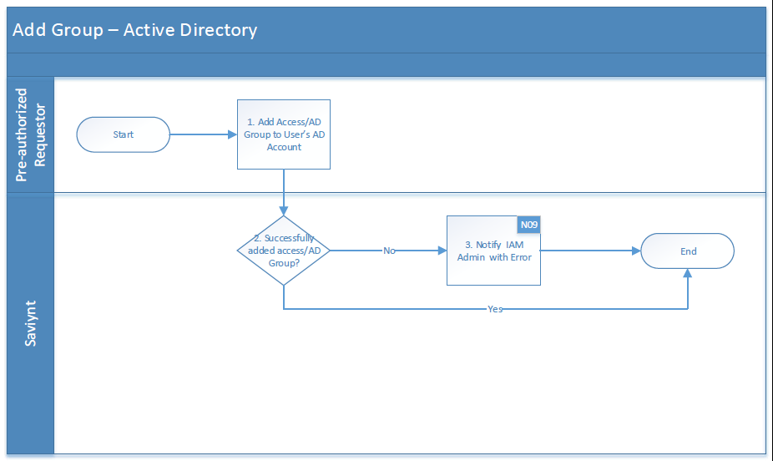
Table 13: Provisioning – Active Diretory Groups
Process Description | The system shall provide a web interface to users, their managers or IAM administrators to add access within connected systems.
Actors | - Saviynt  - Pre-authorized Requestor (Beneficiary, Manager or IAM Admin)
Preconditions | - The requester is authorized to add AD groups from Beneficiary on Saviynt.
Triggers | - Requester submits the AD group add request within the Saviynt.
Process Details | This section provides additional details about the process flow defined above. Each number corresponds to equivalent step on the flow diagram. Additional details may include appropriate references for evaluation logic, transformation mappings.  - Add group to User’s AD account  - Raise a request to add AD group as applicable.  - This task will be performed by a pre-authorized requester and approval will be done as mentioned in process 3.1.2.  - Successfully added AD Group?  - Requested AD group will be added to AD profile of the user.  - Notify IAM Admin with error  - Send an email notification to the IAM Administrator mailbox.
Post Condition | - Access to AD Group is appropriately added for the Requestee on the target system.
Exceptions | - Failure of API should trigger an email-based notification to the IAM Support mailbox using email template N09.
Assumptions | NA

Process#3.5 - Deprovisioning – Active Directory Groups
Figure 12: Deprovisioning – Active Directory Groups
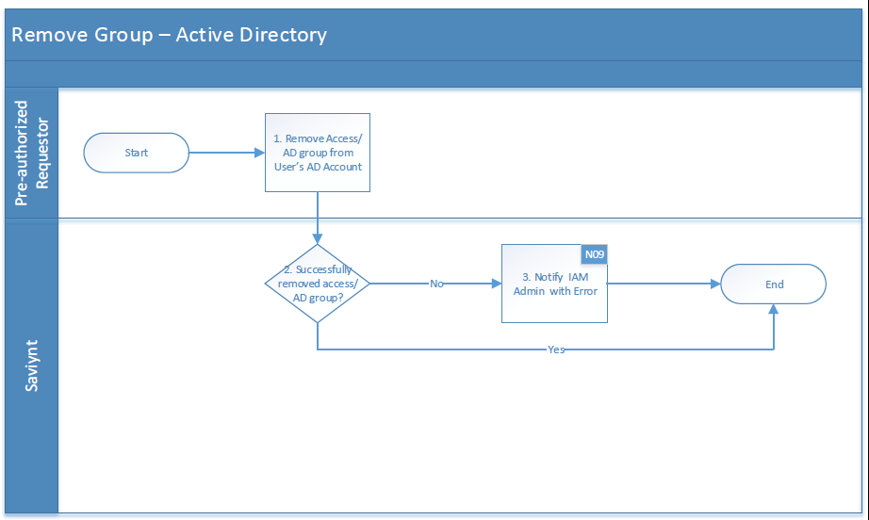
Table 14: Deprovisioning – Active Directory Groups
Process Description | The system shall provide a web interface to users, their managers or IAM administrators to remove access or accounts within connected systems.
Actors | - Saviynt  - Pre-authorized Requestor (Beneficiary, Manager or IAM Admin)
Preconditions | - The requester is authorized to remove access from Beneficiary on Saviynt.
Triggers | - Requester submits the access removal within the IAM system
Process Details | This section provides additional details about the process flow defined above. Each number corresponds to equivalent step on the flow diagram. Additional details may include appropriate references for evaluation logic, transformation mappings.  - Remove Access from User’s account  - Raise a request to remove AD group as applicable.  - This task will be performed by a pre-authorized requester and approval will be done as mentioned in table 10.  - Successfully removed Group?  - Requested AD group will be removed from AD profile of the user from AD system.  - Notify IAM Admin with error if operation fails.  - Send an email notification to the IAM Administrator mailbox.
Post Condition | - Access to AD group is appropriately removed for the Requestee on the target system.
Exceptions | - Failure of API should trigger an email-based notification to the IAM Support mailbox using email template N07.
Assumptions | NA

Process#3.6 – Deprovisioning – Active Directory
Figure 13: Deprovisioning – Active Directory
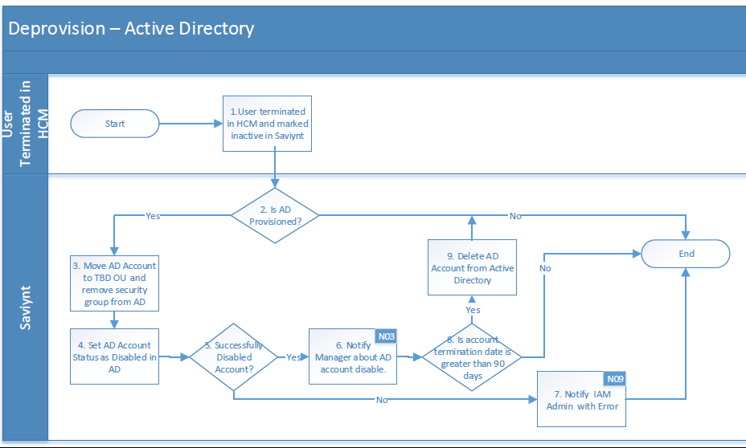
Table 15: Deprovisioning – Active Directory
Process Description | The solution shall have the ability to automatically connect to the up-stream HR system, identify users whose profile got inactivated, and disable associated Active Directory accounts in connected downstream systems.
Actors | HR, Saviynt
Preconditions | - HR Administrator has terminated an Employee record on Oracle HCM.  - User’s termination date has been notified to HR  - HR must update the employee end date and status in an authoritative source.  - HR changes the user’s status to ‘’Terminated” and set the the termination date  - IAM system synchronizes with an Authoritative source to find the user as terminated
Triggers | - HR Administrator has updated an Employee record on Oracle HCM in fields that are significant for Saviynt.  - Identity is updated on the Saviynt via the Authoritative source reconciliation process.  - Employee status changes to ‘Inactive’ in Saviynt.
Process Details | - User terminated in HCM and marked inactive in Saviynt.  - HR Administrator update the users End date and status to terminate.  - The existing active users identity gets disabled on Saviynt.  - Refer to Appendix A for HCM to Saviynt Profile Attributes Mapping.  - Is AD Provisioned?  - Saviynt Identity must have at least 1 Active Directory account linked to it.  - Move AD Account to TBD OU and remove security group from AD.  - Move AD account to TBD OU  - Security group assigned to the user are removed  - Set Active Directory Account Status to Disabled  - Refer to Appendix B for corresponding “Disable” status on AD.  - Notify Manager about Terminated User  - Refer to Appendix A to identify the user’s Manager on Saviynt SSM.  - Refer to Appendix G for the Email notification template N03.  - Refer to Appendix G for the Email notification template N10.  - Is account termination date is greater than 90 days and mail attribute is empty in AD  - Active Directory account will be deleted after 90 days once it’s disabled.  - If termination date is less than 90 days then account stays in TBD OU in Disable state.  - Notify IAM Admin with error if operation fails.  - Send an email notification to the IAM Administrator mailbox.
Post Condition | - IAM system must disable the identity and disable Active Directory account in target applications.
Exceptions | - Downstream provisioning may fail due to data discrepancy or network issues. In such a case, send an email to the IAM Support mailbox using template N07.
Assumptions | - HR System has Employee, Pending Worker records and Contingent Worker data. Saviynt should be able to pull all records.  - There are no duplicate entries in the HR System for any given Employee.  - Critical attributes that indicate the action that is required for the given record (i.e. create, update, enable and disable) are correctly updated in the HR System.  - Connection to Active Directory is always available.

Process#3.7 – Deprovisioning – O365
Figure 14: Deprovisioning – O365
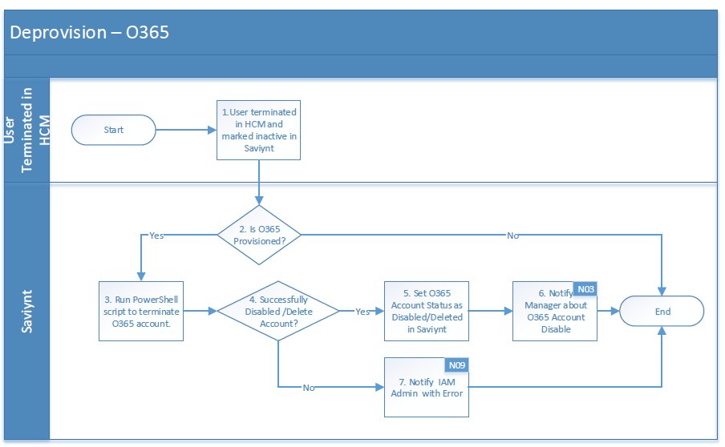
Table 16: Deprovisioning – O365
Process Description | The solution shall have the ability to automatically connect to the up-stream HR system, identify users whose profile got inactivated, and disable associated Active Directory accounts in connected downstream systems.
Actors | HR, Saviynt
Preconditions | - HR Administrator has updated an Employee record on Oracle HCM in fields that are significant for Saviynt.  - User’s termination date has been notified to HR  - HR must update the employee end date and status in an authoritative source.  - HR changes the user’s status to ‘’Terminated” and set the the termination date  - IAM system synchronizes with an Authoritative source to find the user as terminated
Triggers | - HR Administrator has updated an Employee record on Oracle HCM in fields that are significant for Saviynt.  - Identity is updated on the Saviynt via the Authoritative source reconciliation process.  - Employee status changes to ‘Inactive in Saviynt.
Process Details | - User terminated in HCM and marked inactive in Saviynt.  - HR Administrator update the users End date and status to terminate.  - The existing active users identity gets disabled on Saviynt.  - Refer to Appendix A for HCM to Saviynt Profile Attributes Mapping.  - Is O365 Provisioned?  - Saviynt Identity must have at least 1 O365 account linked to it.  - Run PowerShell script to terminate O365 account  - Set O365 Account Status to Disabled  - Notify Manager about Terminated User  - Refer to Appendix A to identify the user’s Manager on Saviynt SSM.  - Refer to Appendix G for the Email notification template N03.  - Refer to Appendix G for the Email notification template N09.  - Notify IAM Admin with error if operation fails.  - Send an email notification to the IAM Administrator mailbox.
Post Condition | - Saviynt must disable the identity and disable O365 account in target applications.
Exceptions | - Downstream provisioning may fail due to data discrepancy or network issues. In such a case, send an email to the IAM Support mailbox using template N09.
Assumptions | - HR System has Employee, Pending Worker records and Contingent Worker data. Saviynt should be able to pull all records.  - There are no duplicate entries in the HR System for any given Employee.  - Critical attributes that indicate the action that is required for the given record (i.e. create, update, enable and disable) are correctly updated in the HR System.

Process#3.8 – Enable – Active Directory
Figure 15: Enable – Active Directory
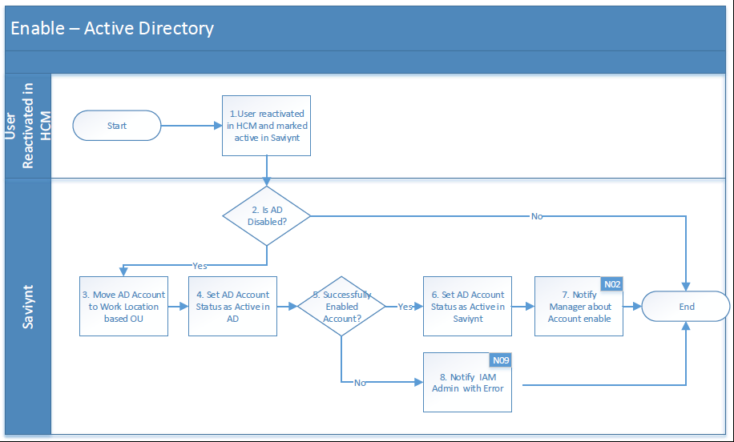
Table 17: Enable – Active Directory
Process Description | The solution shall have the ability to automatically connect to the up-stream HR system, identify users whose profile got activated, and enabled associated Active Directory accounts in connected downstream systems.
Actors | HR, Saviynt
Preconditions | - HR Administrator has re-hired an existing Employee record on Oracle HCM.  - Saviynt triggers the user import job to fetch all the Active and Inactive Employee records from Oracle HCM.
Triggers | - HR Administrator has updated an Employee record on Oracle HCM in fields that are significant for Saviynt.  - Identity is updated on the Saviynt via the Authoritative source reconciliation process.  - Employee status changes to ‘Active’ in Saviynt.
Process Details | - User reactivated in HCM and marked active in Saviynt.  - HR Administrator update the users status to active.  - The existing inactive users identity gets enabled on Saviynt.  - Refer to Appendix A for HCM to Saviynt Profile Attributes Mapping.  - Is AD Disabled?  - Saviynt Identity must have at least 1 Active Directory account linked to it in Disabled status.  - Move AD Account to Location Based OU in AD.  - Set Active Directory Account Status to Enabled  - Refer to Appendix B for corresponding “Enable” status on AD.  - Notify Manager about Enable Account.  - Refer to Appendix A to identify the user’s Manager on Saviynt.  - Refer to Appendix G for the Email notification template N02.  - Notify IAM Admin with error if operation fails.  - Send an email notification to the IAM Administrator mailbox.
Post Condition | - Saviynt must activate the identity and enable Active Directory account in target applications.
Exceptions | - Downstream provisioning may fail due to data discrepancy or network issues. In such a case, send an email to the IAM Support mailbox using template N09.
Assumptions | - HR System has Employee, Pending Worker records and Contingent Worker data. Saviynt should be able to pull all records.  - There are no duplicate entries in the HR System for any given Employee.  - Critical attributes that indicate the action that is required for the given record (i.e. create, update, enable and disable) are correctly updated in the HR System.  - Connection to Active Directory is always available.  - Saviynt will move the AD account to Location based OU only.

Appendix

Appendix A: Oracle HCM to Saviynt Identity Attributes Mapping
Oracle HCM system is the authoritative source of identities for employees in the enterprise. Consolidated user information is retrieved by using emps and Worker API. This consolidated view is used to pull employees’ identity attributes into Saviynt.

Table 18: Oracle HCM to Saviynt SSM Identity Attributes Mapping
HCM Attribute | Saviynt Attribute | Required/Optional
FirstName | firstName | Required
MiddleName | middleName | Optional
LastName | lastName | Required
DisplayName | displayName | Optional
PreferredName | preferedFirstName | Optional
PersonNumber | employeeId | Required
HireDate | startDate | Required
TerminationDate | enddate | Optional
WorkerType | employeeType | Required
JobCode | jobcode | Required
Name | title | Required
LocationCode | locationnumber | Required
DepartmentName | departmentname | Required
LegalEmployerName | companyname | Required
AssignmentStatusType | statuskey | Required
Hire Date/Projected Start Date | startDate | Required
LocationName | locationdesc | Required
Address1 | street | Required
TownOrCity | city | Required
Region2 | state | Required
Country | country | Required
AssignmentCategory | employeeclass | Required
PostalCode | customproperty1 | Required
PersonID | customproperty6 | Required
ManagerAssignmentId | customproperty7 | Required
AssignmentId | customproperty8 | Required
LocationId | customproperty9 | Required
JobId | customproperty10 | Required
WorkAtHomeFlag | customproperty11 | Optional
ActionCode | customproperty12 | Required
assignmentsDFF.payRule | customproperty16 | Required

The identity state changes during the employee’s lifecycle in the organization. State changes are used by Saviynt to trigger various lifecycle events, which perform access to provisioning and de-provisioning. State changes are triggered by a trusted source aggregation or by external events like Suspension/Termination by managers. Provisioning/De-provisioning to target applications is carried out by the Identity Access Rules defined in Saviynt. We primarily use technical rules and User update rules, which are part of Identity access rules, to handle identity state change.

Identity Access Rules Triggers
The following section provides details about the Identity access rules trigger to import users into Saviynt from Oracle HCM.
Table 19: Identity Access Rules Triggers
Personnel State | Attributes | Identity Access Rules Triggers
New Hire | AssignmentStatusType=Active  &  Hire Date is greater than 14 days of the current date | - Technical Rules -To provide birthright access.  - User Update Rule -To provide access to the roles/target systems based on the user’s attributes.
Suspended/Terminated | AssignmentStatusType=Inactive  &  Current date <=End date | - User Update Rule - To disable/revoke access to the provisioned roles/target systems.
Rehire | AssignmentStatusType==Active  &  Hire Date is greater than 14 days of the current date | - Technical Rules- To provide birthright access.  - User Update Rule- To provide access to the roles/target systems based on the user’s attributes.

Appendix B: Saviynt to Active Directory Mapping
Active Directory will be treated as an end target application that can be a birthright application or can also be requested by end-users via Saviynt UI. The below table shows the attribute mapping between Saviynt and Active Directory.
Table 20: Saviynt to Active Directory Mapping
Saviynt Attribute Name | Active Directory Attribute Name | Required for Create | Required for Update | Note
UserName | sAMAccountName | Yes | No
locationdesc + street | streetAddress | Yes | Yes
manager | manager | Yes | Yes
title | title | Yes | Yes
employeeId | employeeNumber | Yes | Yes
customproperty16 | employeeType | Yes | Yes
firstName | givenName | Yes | Yes
lastName | sn | Yes | Yes
middleName | initials | Yes | Yes
userName@hormel.com | userPrincipalName | Yes | Yes
statuskey | userAccountControl | Yes | No
departmentname | department | Yes | Yes
locationdesc | company | Yes | Yes
state | st | Yes | Yes
city | l | Yes | Yes
enddate | accountExpires | Yes | Yes
country | c | Yes | Yes
systemusername | displayname | Yes | Yes
 | pwdLastSet | Yes | No | If user is non employee and needs to be created in External OU then value should be set as -1 else 0
companyname | physicalDeliveryOfficeName/office | Yes | Yes
Customproperty1 | postalCode | Yes | Yes
systemusername | cn/dn | Yes | No
Customproperty17 | extensionAttribute1 | Yes | Yes
Customproperty18 | co | Yes | Yes

Default AD Groups Provision for Users
The following section provides details about the mapping of Default group provision to users type.
Table 21: Default AD Group Provision
Employee Type | Group name
Employee | <Groups are not yet finialize with Hormel team>

User Status Mapping in Active Directory and Saviynt
The following section provides details about user status mapping in Active Directory and Saviynt.
Table 22: User Status Mapping in Active Directory
Operation | User Account Control Description | User Account Control Value in Active Directory (AD) | Status in Saviynt
Enable | NORMAL_ACCOUNT, Password Required | 512 | Active
Disable | Disabled Account, Password Required | 514 | Inactive
Enable | Enabled, Password Not Required | 544 | Active
Disable | Disabled, Password Not Required | 546 | Inactive
Enable | Enabled, Password Never Expire | 66048 | Active
Disabled | Password Never Expire | 66050 | Inactive
Disabled | Disabled, Password Never Expire & Not Required | 66082 | Inactive

Appendix C: Saviynt SSM to O365 Mapping
Below is the attribute mapping between Saviynt and O365.

Table 23: Birth right Rules
Saviynt | PowerShell | Required/Optional
username | user | Required
customproperty3 | domain | Required

Appendix D: Birth right Rules
The following section provides details about the Bright rule to trigger for provision the account and groups/entitlements.
Table 24: Birth right Rules
Term | Description
Birth right Account | Birth right account provisioning automates account provisioning to new hires based on a few HR attributes. If the user is salaried employee within CORP location, They'll get both AD and Mailbox.
Birth right groups | Birth right groups provisioning automates role provisioning to users based on a few HR attributes.If the user is salaried employee within CORP location they will get the AD Birth Right groups as per section 4.2.1

Appendix E: Business Rules
This section lists and describes the business rules applicable to the proposed system.
Table 25: Birth right Rules
Business Rule Id | Rule Name | Rule Description
BR001 | HR Recon Rule | Person Number in HCM = EmployeeID in Saviynt
BR002 | Active Directory Recon Rule | EmployeeID in Saviynt = EmployeeNumber in Active Directory
BR003 | O365 Recon Rule | User Name in Saviynt = SamAccountName in Active Directory
BR004 | UserName Generation Rule | The User Name generation logic will follow the below order for generating User Name until a non-duplicate User Name is generated.  - FirstNameInitialMiddleNameInitialLastNameFull  - FirstNameInitialMiddleNameInitialLastNameFull(1-9)  - FirstNameInitialLastNameFull  - FirstNameInitialLastNameFull(1-9)  If length of user name is greater than 22 than trim the lastname. If multiple fistname are there than concatenate all the first names.  If there are multiple Last Names then the concatenate all the last names.
BR005 | Valid Email Domain For User Rule | List of valid email domains for Hormel:  - Applegate.com  - Columco.com  - Fontanini.com  - Alselectfoods.com  - Dansprize.com  - Centuryfoods.com  - Burkecorp.com  - Mmxfoods.com  - Justins.com  - Hfcpartners.com  - Hormel.com  - J-ots.com  - Hfc.ad
BR006 | Email ID Generation Rule | - UserName@domain.com  Domain will be selected based on users location.
BR007 | CN Generation Rule | The CN generation logic will follow the below order for generating CN until a non-duplicate CN is generated.  - LastName_FirstName_MiddleInitial  - LastName(1-9)_FirstName_MiddleInitial  - LastName_FirstName  - LastName(1-9)_FirstName

Appendix F: Password Policy
The following section provides details about the Active Directory and Saviynt Password Policy.
Table 26: Active Directory Password Policy
Policy Name | Hormel Active Directory and Saviynt Password Policy
Policy Description | This is Active Directory and Saviynt password policy for Hormel users.
Policy Scope | USER/Active Directory account
Minimum Numeric Characters
Minimum Alpha Numeric Characters
Minimum Alphabet Characters
Minimum Lowercase Characters
Maximum Repeated Characters
Minimum Special Character
Minimum Unique Characters
Minimum Uppercase Characters
Minimum Length | 12
Last Password History | 24
Password should not include the username
Password last for 90 days

Appendix G: Email Notification
The following section provides basic details about the type of email notification and recipients. Email Templates, including additional details of users that need to be sent will be finalized during design and implementation.
Table 27: Email Notification
No | Notification Name | From | To
N01 | Send the notification to the Manager with Account details. | <Get it from Hormel> | Manager
N02 | Send the notification to the Manager with Rehired Account details. | <Get it from Hormel> | Manager
N03 | Send the notification to the Manager about user terminated | <Get it from Hormel> | Manager
N05 | Notify the requester and requestee about the rejected request. | <Get it from Hormel> | Requester
N06 | Notify the requester and requestee about the new access details requests. | <Get it from Hormel> | Requester
N07 | Notify the approver about the new request assigned for approval | <Get it from Hormel> | Approver
N08 | Send reminder notification to approver on 3rd day | <Get it from Hormel> | Approver
N09 | Notify IAM Administrators about various errors in the system (e.g. provisioning failure, use disablement failure or any other abnormal system error) | <Get it from Hormel> | IAM Administrator
N10 | Notify the requester about the access request expiry on 10th day if no action has been taken on request till that time. | <Get it from Hormel> | Requester

